**ESE-3014 Lab**

**Interfacing communication – WiFi**

**Task: Monitoring local WiFi signals**

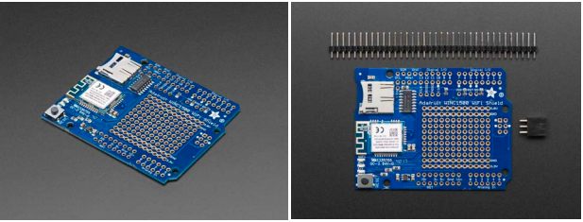

1. Connect your Adafruit WINC1500 WiFi Shield with PCB Antenna to the Arduino. Ensure pinout selection and soldering are fine. You might use the following reference for this purpose:

<https://learn.adafruit.com/adafruit-winc1500-wifi-shield-for-arduino/wiring-test>

1. Install the required libraries and develop the code to scan the available WiFi signals around you!
2. Monitor the strength of those signals on the serial monitor and record the results!